**LOADING MICROFILM**

1. Pull the silver handle forward until the glass lifts up.

1. Place the microfilm on the left reel. Pulling the film from the top of the reel, run the film under the white roller and the glass.

1. Continue pulling film under the glass pane and under the second white roller. Place film in slot on take up reel.

1. Push silver handle back. This will push the glass down on the film and you can now line the film up under the microfilm reader’s light.
2. Open the viewscan software.

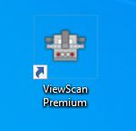

1. To move the film, you can either press the physical buttons on the machine or the software. The red buttons move the film fast, the white buttons move it slower. If you need to scroll through the film quickly, pull the silver handle forward until the glass lifts, then press the red button.

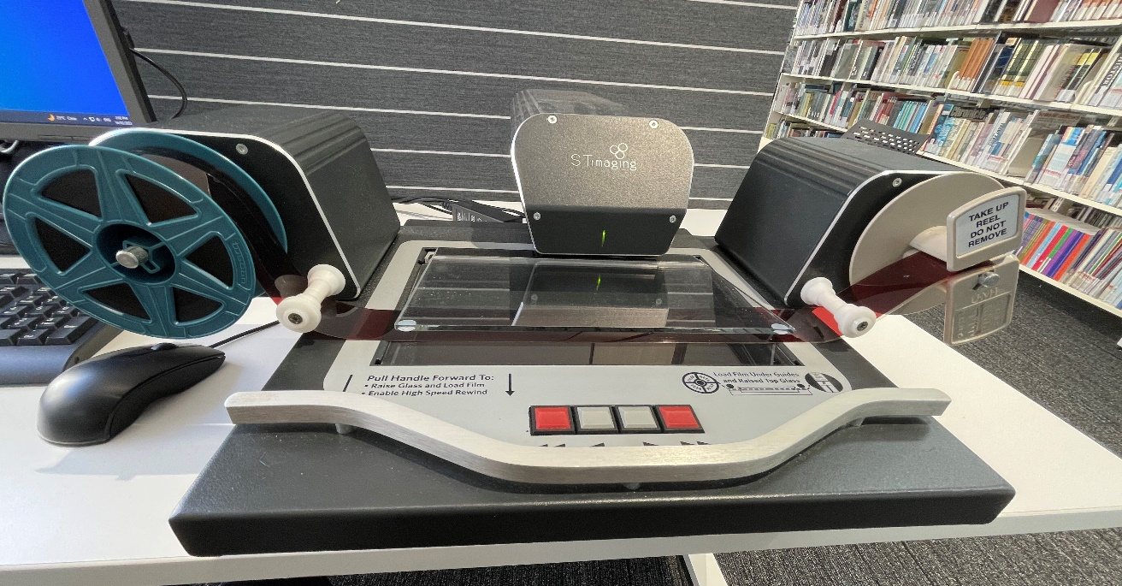

**USING THE VIEWSCAN SOFTWARE**

If the film is upside down, click on the ‘Flip Vertical’ button

If the film is ‘negative’, click here to make it positive

Use the zoom buttons to focus the film if needed